Social Prescribing Link Workers
What the public need to know about social prescribers and how to access them.

Communications toolkit

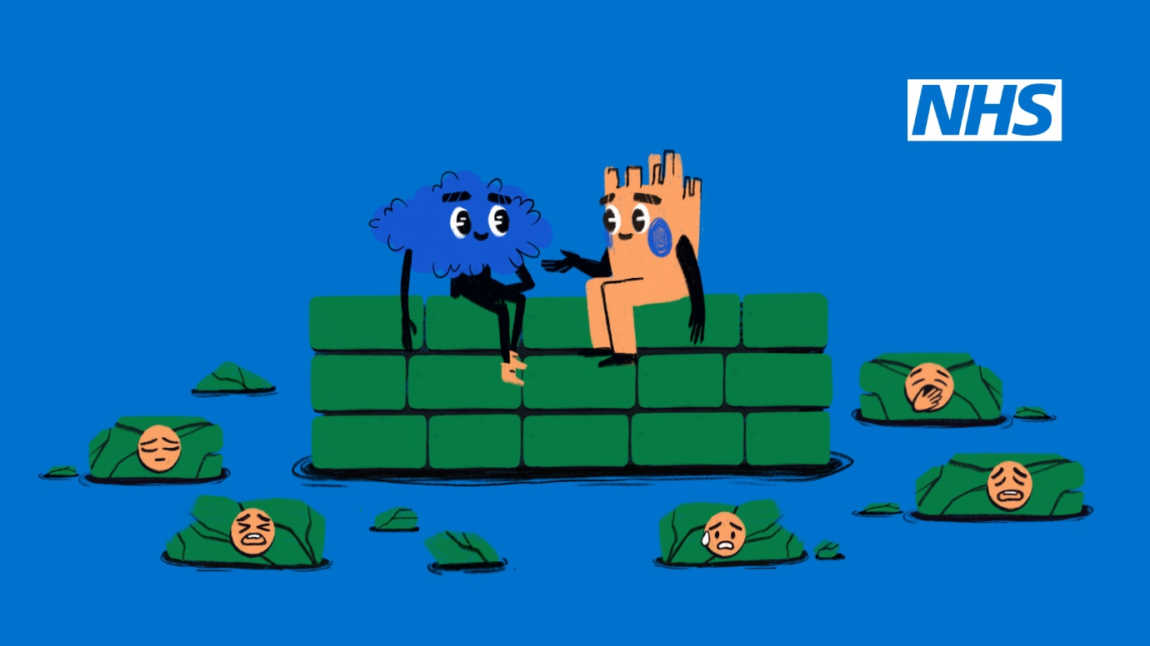

These communications assets have been produced as a collaborative effort by the NEY Primary Care Transformation team and a team of social prescribers from the North East and Yorkshire region to assist communications and engagement colleagues in promoting the role of social prescribers to the public.

If you would like more information, please contact carole.wirszyla@nhs.net

Launch date: 16 November 2023

Background

As per the network contract DES, the Additional Roles Reimbursement Scheme (ARRS) staff are central to personalised care delivery by the multi-disciplinary team, particularly Social Prescribing Link Workers, Health & Wellbeing Coaches and Care Coordinators. The DES states that implementing proactive social prescribing can impact high frequency users, address health inequalities, and support hospital discharge.

One of the three essential elements of the Fuller Stocktake Report, published in May 2022, is to provide more proactive, personalised care from a multidisciplinary team of professionals.

The NHS Long Term Workforce Plan, published in June 2023, outlines three key priorities: Train, Retain and Reform the workforce. The reform element outlines the need to work and train differently using a range of roles within the multidisciplinary team to enhance service delivery.

The Delivery Plan for Recovering Access to Primary Care published in May 2023 supports continued funding for the Additional Roles Reimbursement Scheme to build capacity in the primary care workforce. The plan also supports implementation of a Modern General Practice approach. Both these actions promote social prescribing services to help reduce pressure on GP services and ensure patients are seen by the most appropriate healthcare professional for their needs.

Social prescribing is a dynamic approach to healthcare that acknowledges the connection between an individual's wellbeing and their social, economic, and environmental circumstances. Social prescribing link workers (SPLWs) also known as social prescribers, are part of the general practice multidisciplinary team and act as links between medical professionals, community resources, and individuals seeking holistic health and wellbeing.

By providing a safe space and a listening ear and by taking the time to help people find solutions to things they find challenging, social prescribers can help reduce pressure on GP appointments by supporting non-medical care needs, subsequently fostering healthier communities.

Research into existing communications materials and discussions with social prescribing teams on the ground revealed there was a lot of misunderstanding about the services provided by social prescribers, how and where to access them and why.

It was determined there was a need to promote social prescribing with a message that informs and entertains; encourages questions yet inspires confidence and is delivered in formats that are engaging and inclusive.

The message was developed with input from ten social prescribers across the region to target the audience needs more accurately and to encourage ownership.

Key messages

Improve understanding of social prescribing (SP), explain why it may be a better option than seeing a GP, describe what services social prescribing link workers provide and show how they can help people who are struggling.

What social prescribers do:

- Provide a safe space and a listening ear.
- Help people find solutions to problems using available local/national resources.
- Provide connections(signposting) and follow-up.
- Address people’s needs in a flexible way.
- Help introduce people to support groups.
- Break down barriers/anxiety about seeking help – service is available to all.
- Encourage mindfulness and self-care through a holistic approach.
- Provide reassurance to encourage people to reach out.
- Give longer appointment times.

Logistics

- Create message with input from SPs working in NEY.
- Produce abstract images to be inclusive of protected characteristics.
- Address language inequalities with voiceover and translated subtitles.
- Include closed captions on animation for those who are hearing impaired
(A BSL version may be available later, depending on funding).
- Use simple language and images that tell the story to help those with poor literacy skills.
- Develop resources that can complement communication work done nationally, regionally and at ICB level to be cascaded widely through networks to the public.

Contact carole.wirszyla@nhs.net for information about the resources. Direct general enquiries about social prescribing to england.ney.pctransformation@nhs.net

An abstract animation has been created that is available in ten different languages commonly spoken in the North East and Yorkshire region, along with a social media short clip and a non-digital poster/flyer for downloading.

The short social media animation can be used to promote social prescribing online and the full animation can be used on digital screens in GP surgeries, pharmacies, Urgent and Emergency Care settings, community hubs, and in hospital waiting rooms. The poster/flyer can be downloaded and printed for use in community settings where digital media is not readily accessible to promote social prescribing across hard-to-reach populations.

4. Resources

- Link to animation (TRT 1min 27secs) – page 4
- Link to translated versions of animation (10 languages) – page 4
- Link to social media short animation (TRT 39secs) – page 4
- Social media suggested content – page 4-8
- Poster/leaflet to download – page 8
- Media release – page 8-9
- Newsletter/bulletin content – page 9

Weblink to full animation and translated versions: NHS England – North East and Yorkshire (Meet Your General Practice Team)

Animation

The full animation and social media short version can be found in the Social Prescriber toolkit along with a downloadable poster/leaflet and some image assets if you wish to create your own versions.

Translated versions of animation

The animation has been translated and is available in the following ten languages here: Urdu, Slovak, Romanian, Punjabi, Portuguese, Polish, Kurdish, Gujarathi, Bengali and Arabic.

Or, there are YouTube links to the translated versions at the bottom of the Social Prescribing Link Worker page.

Social media short version of animation

This short version of the animation can be used on social media.

Social media suggested content
Twitter/X

Feeling overwhelmed and struggling to cope? Ask about #socialprescribers at your doctor’s surgery to help you find solutions to things that are difficult. NHS England — North East and Yorkshire » Social Prescribing Link Worker

#socialprescribers are part of your general practice team and can help you find solutions to things that are difficult when you’re feeling overwhelmed. NHS England — North East and Yorkshire » Social Prescribing Link Worker

General practice teams are made up of a range of health professionals including social prescribing link workers. Search NHS social prescribers to learn more. NHS England — North East and Yorkshire » Social Prescribing Link Worker

Facebook

In general practice, people work in several different roles alongside your GP to help you with your health and wellbeing needs. Together, they can get you the right care from the right healthcare professional as quickly as possible. Social prescribing link workers (also known as social prescribers) can help you when you’re struggling to find solutions to things that are difficult. Check out Meet your GP Team to find out how a social prescriber can help you.
#SocialPrescribers #MeetYourGPTeam #SocialPrescribingLinkWorkers #SPLW

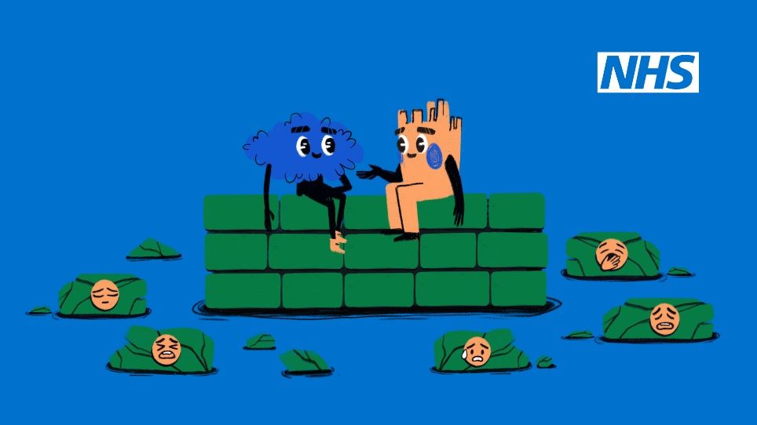

Instagram and other social media

Feeling overwhelmed and wondering who you can turn to for help? Social prescribers are part of your local #GeneralPracticeTeam and can help you when you’re struggling.
#SocialPrescribers #MeetYourGPTeam #SocialPrescribingLinkWorkers #SPLW

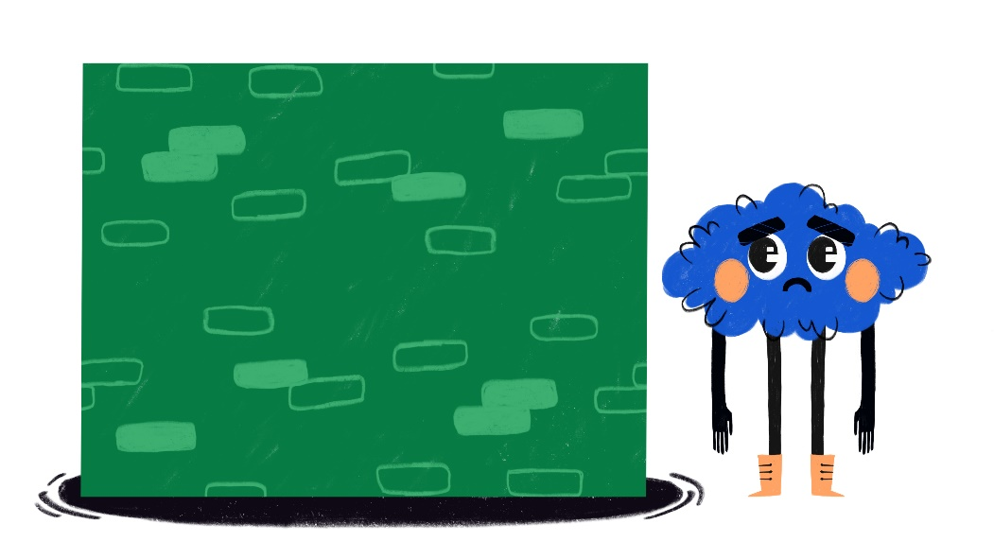

Feeling overwhelmed and struggling to manage everyday activities? Social prescribers are part of your local #GeneralPracticeTeam and offer longer appointment times to help you find solutions to things that are difficult.
#SocialPrescribers #MeetYourGPTeam #SocialPrescribingLinkWorkers #SPLW

Feeling overwhelmed and struggling to manage everyday activities? Social prescribers are part of your local #GeneralPracticeTeam and can help connect you with essential, non-medical services.
#SocialPrescribers #MeetYourGPTeam #SocialPrescribingLinkWorkers #SPLW

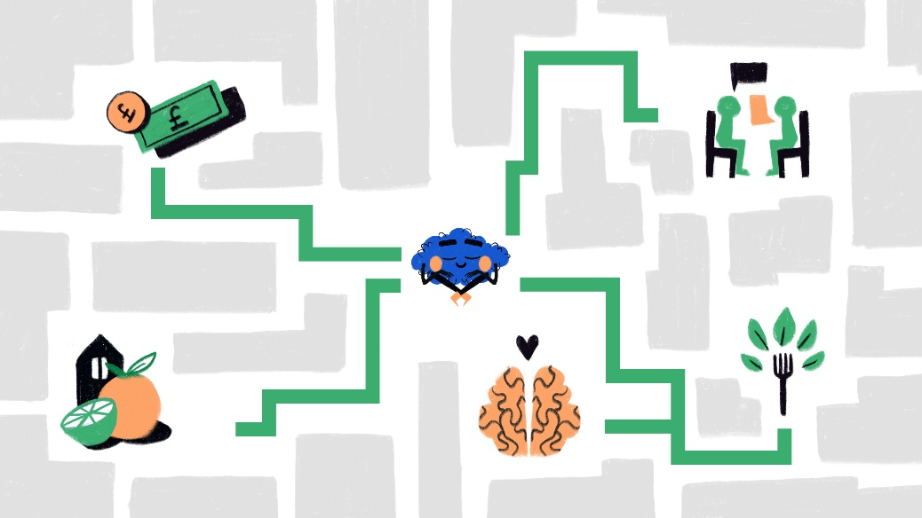

Feeling overwhelmed and wondering who you can turn to for help? Social prescribers are part of your local #GeneralPracticeTeam and can introduce you to local support or activity groups.
#SocialPrescribers #MeetYourGPTeam #SocialPrescribingLinkWorkers #SPLW
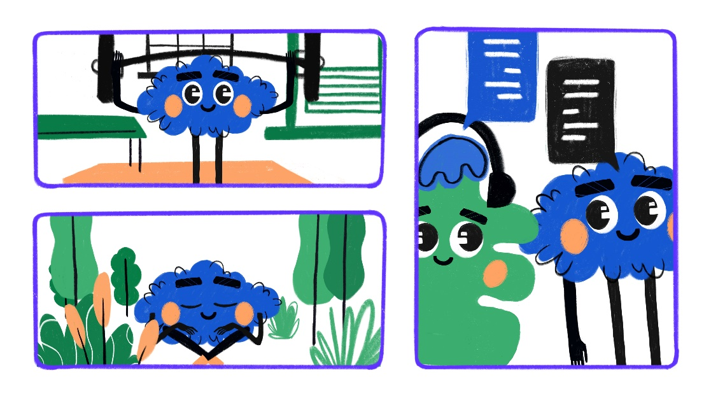

Feeling overwhelmed and wondering who you can turn to for help? Social prescribers are part of your local #GeneralPracticeTeam. Accessing a social prescriber is easy. You can self-refer by asking at your doctor’s surgery or you can be referred by others in the health and social care community.
#SocialPrescribers #MeetYourGPTeam #SocialPrescribingLinkWorkers #SPLW

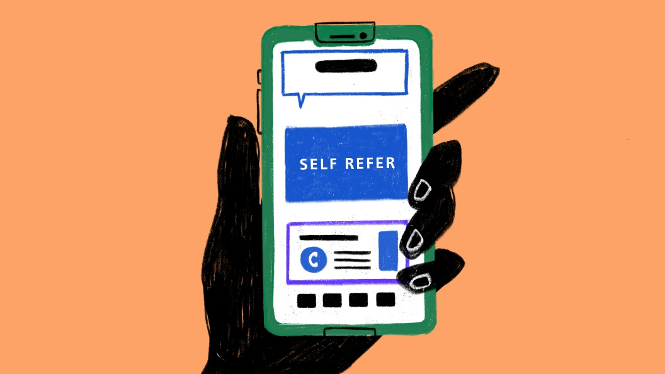

Feeling overwhelmed and struggling to manage everyday activities? Social prescribers are part of your local #GeneralPracticeTeam. Accessing a social prescriber is easy. You can self-refer by asking at your doctor’s surgery or you can be referred by others in the health and social care community.
#SocialPrescribers #MeetYourGPTeam #SocialPrescribingLinkWorkers #SPLW

Not sleeping? Pressure at work? Feeling lonely? You may think you need to talk to your GP, but maybe a #socialprescriber can help. Learn more https://bit.ly/46hvRS2
#SocialPrescribers #MeetYourGPTeam #SocialPrescribingLinkWorkers #SPLW

Not sleeping? Pressure at work? Feeling lonely? Ask about #socialprescribers at your doctor’s surgery, watch this quick video https://bit.ly/46hvRS2 or search NHS social prescribers on the internet to learn more about how they can help.
#SocialPrescribers #MeetYourGPTeam #SocialPrescribingLinkWorkers #SPLW

Mental health struggles? Financial troubles? Feeling anxious? You may think you need to talk to your GP, but maybe a #socialprescriber can help. Find out more here https://bit.ly/46hvRS2
#SocialPrescribers #MeetYourGPTeam #SocialPrescribingLinkWorkers #SPLW

Mental health struggles? Financial troubles? Feeling anxious? Ask about #socialprescribers at your doctor’s surgery, watch this quick video https://bit.ly/46hvRS2 or search NHS social prescribers on the internet to learn more about how they can help.
#SocialPrescribers #MeetYourGPTeam #SocialPrescribingLinkWorkers #SPLW

Relationship problems? Carer stress? Housing issues? You may think you need to talk to your GP, but maybe a #socialprescriber can help. Watch this quick video to learn more https://bit.ly/46hvRS2
#SocialPrescribers #MeetYourGPTeam #SocialPrescribingLinkWorkers #SPLW

Relationship problems? Carer stress? Housing issues? Ask about #socialprescribers at your doctor’s surgery, watch this quick video https://bit.ly/46hvRS2 or search NHS social prescribers on the internet to learn more about how they can help.
#SocialPrescribers #MeetYourGPTeam #SocialPrescribingLinkWorkers #SPLW

#GeneralPracticeTeams are made up of a range of health professionals. Together, they help get you the right care from the right healthcare professional. See Meet your General Practice Team to find out how a Social Prescribing Link Worker can help you prioritise your health and wellbeing.
#SocialPrescribers #MeetYourGPTeam #SocialPrescribingLinkWorkers #SPLW

This Autumn/Winter, your #GeneralPracticeTeam is here to help you prioritise your health and wellbeing. Having a range of health professionals at your general practice means you can get the most appropriate care as quickly as possible. Learn how a Social Prescribing Link Worker can help you. Meet your General Practice Team.
#SocialPrescribers #MeetYourGPTeam #SocialPrescribingLinkWorkers #SPLW

Poster/leaflet to download
This image can be downloaded and printed off as a full-size poster or a smaller-sized leaflet.
Should you need the poster/leaflet to be re-created in one of the ten languages listed above, please email carole.wirszyla@nhs.net.
Media release for local adaptation

Feeling overwhelmed? A social prescriber might be just what you need

When you’re feeling overwhelmed and don’t know where to get help, you may think you need to see your doctor when in fact the best person to help you could be a social prescribing link worker.

A range of health and wellbeing professionals are being added to general practice teams as part of a programme to expand the NHS workforce—some work at your doctor’s surgery and others work in the wider community to help you get the most appropriate care when you need it.

One of the newer roles in the GP team is the social prescribing link worker (SPLW), sometimes referred to as a social prescriber—they are available to everyone.

Michelle Hartley, Social Prescribing Advisor for LiveWell – Doncaster Social Prescribing said, “Social prescribers help you find your own solutions to things that are difficult by hearing what matters to you and helping you access the right support at the right time. They connect you with the essential non-medical services, support, or activity groups that you choose to regain control of your health and wellbeing.”

This modern approach is part of the plan NHS England is implementing to prioritise people’s health and wellbeing while improving access to primary care services. They recently launched a new public campaign to explain the changes taking place that will improve the way people access and receive care from general practice.

The first phase of the campaign explains some of the roles of different health and care staff in general practice teams.

Dr Faisel Baig, GP & Medical Director for Primary Care at NHS England – North East and Yorkshire said: “As record numbers of people are seeking support from their GP practice, the NHS is improving its services by expanding the workforce to meet the demand.

“Having more direct patient care staff like social prescribers means patients can access appropriate specialist support without needing to see a GP first.”

Accessing a social prescriber is easy. You can self-refer by asking at your doctor’s surgery or you can be referred by others in the health and social care community.

Go to the NHS England web page for social prescribers or search NHS social prescribers on the internet to learn more. To find out more about other GP team roles, search meet your GP team on the internet.

Bulletin copy for local adaptation

Social prescribers help people find solutions to things that are difficult

A range of health and wellbeing professionals are being added to general practice teams as part of a programme to expand the NHS workforce: some work at doctor’s surgeries and others work in the wider community to help people get the most appropriate care when they need it.

One of the newer roles in the GP team is the social prescribing link worker (SPLW), sometimes referred to as a social prescriber. They are available to everyone and can help people find solutions to things that are difficult by addressing their needs flexibly, connecting them with essential non-medical services and signposting them to support or activity groups.

This modern approach is part of the plan NHS England is implementing to prioritise people’s health and wellbeing while improving access to primary care services. NHSE recently launched a new public campaign to explain the changes taking place that will improve the way people access and receive care from general practice.

The first phase of the campaign explains some of the roles of different health and care staff in general practice teams.

Go to the NHS England web page for social prescribers or search NHS social prescribers on the internet to learn more. To find out more about other GP team roles, search meet your GP team on the internet.

***END***

